What is Job Approval?
The Job Approval process allows Hiring Managers and supervisors to request approval for a requisition. The requested job is then put through an email-driven approval process before it can be activated. This is taking place of our “Request and Recruiting Form”.
Log in to Paycor. If you aren’t sure if you have access, reach out to Cassidy Leininger at cleininger@csp.edu to create your account.
HOW DO I BEGIN A REQUEST FOR JOB APPROVAL?
- Click the Request Job Approval button in the navigation bar, complete the required fields (FIELDS WITH A STAR):
- Job Title
- Openings
- Location
- Remote Status
- Department
- Hiring Process: Select
- External Application: Select
- Internal Application: Select
- Job Type: Select
- FLSA Status: Select
- Salary Range: Input Salary Range. +/- $2000
- AT THE BOTTOM OF THE FORM, download the “Request & Recruiting Form For Paycor”
- Add in your information
- Attach form back into “Choose a File”
- On the right side, paste in your job description. Don’t worry if the formatting looks weird. HR will clean-up the posting and ensure it fits our standard posting requirements. (Add Supplemental Information, Etc.)

- Once complete, click Next in the upper right corner.

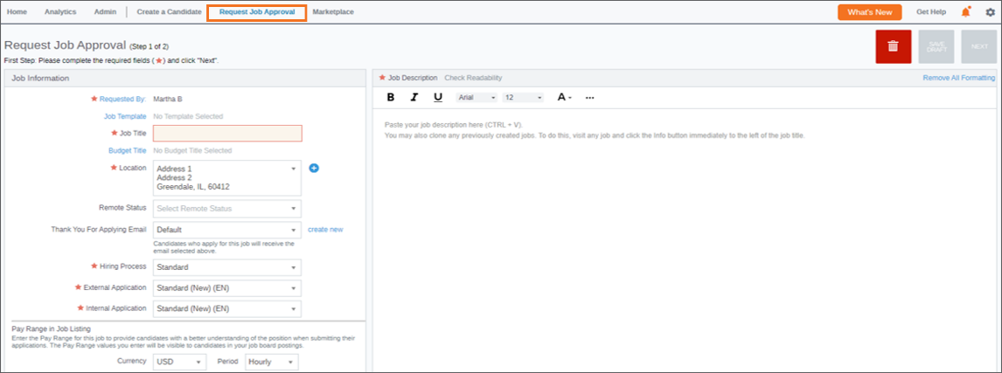
3. Enter an optional comment and click Submit. Recruiting alerts your Approval Manager(s) that you have submitted the request (Cassidy’s name will populate here).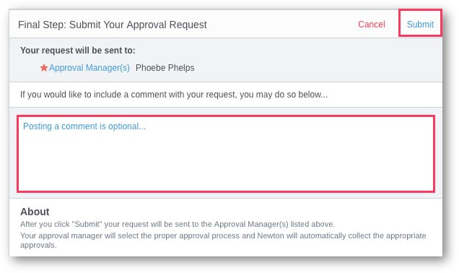
You're finished! Recruiting displays your alert settings for your convenience.
HOW DO I CHECK THE STATUS OF A JOB APPROVAL?
As a Standard User, the Approvals tab on your home dashboard will display all jobs related to you, jobs you’ve requested, and jobs you need to approve. You can see here where the jobs stand in the approval process.
