Move a Candidate to the Back Burner Status for a Job
- Sometimes you are not ready to move forward with a candidate yet, but you don't want to inactivate them outright.
- The Back Burner status is the perfect place for these candidates because they do not clutter up the Home dashboard and they are easily accessible at another time.
Follow these steps to change a candidate's status to Back Burner:
1. In Recruiting, navigate to the candidate's record.
2. Click the appropriate stage for the candidate: Review, Phone Screen, or Interview.
3. Click Back Burner and then click Save.
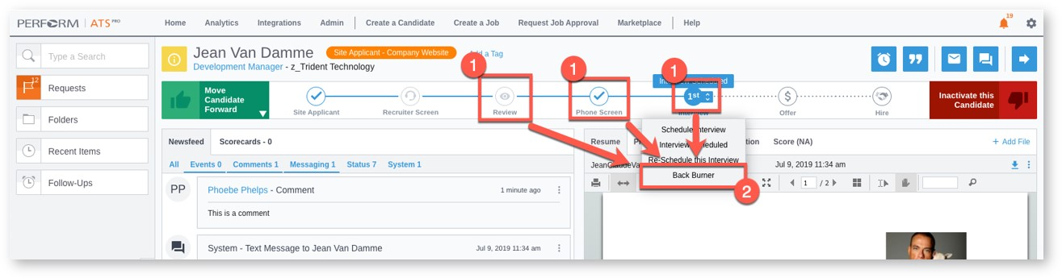
4. To review your candidates in the Back Burner status, on the Home dashboard, click the top-most box to the right of the job information. If the box is grayed out, there are no candidates in the Back Burner status.
