BEFORE YOU CAN EXTEND A VERBAL OFFER TO YOUR CANDIDATE, YOU MUST CONTACT HR TO INITIATE THE BACKGROUND CHECK.

HOW DO I BEGIN A REQUEST FOR OFFER APPROVAL?
Once your candidates background check is completed, Click the Offer Stage badge, and select Request Offer Approval.
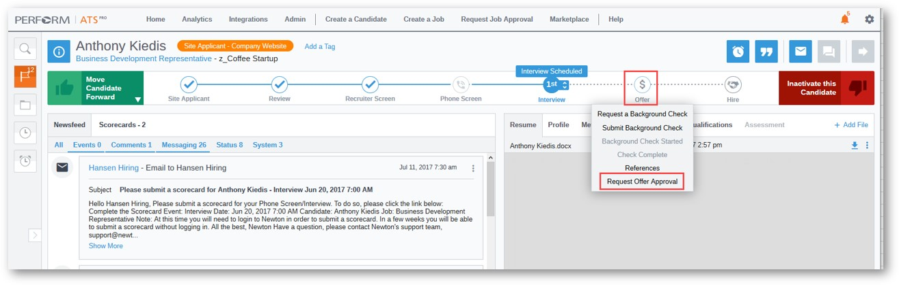
Complete the required fields as well as any optional fields you’d like to fill out, then click Continue in the upper right corner.
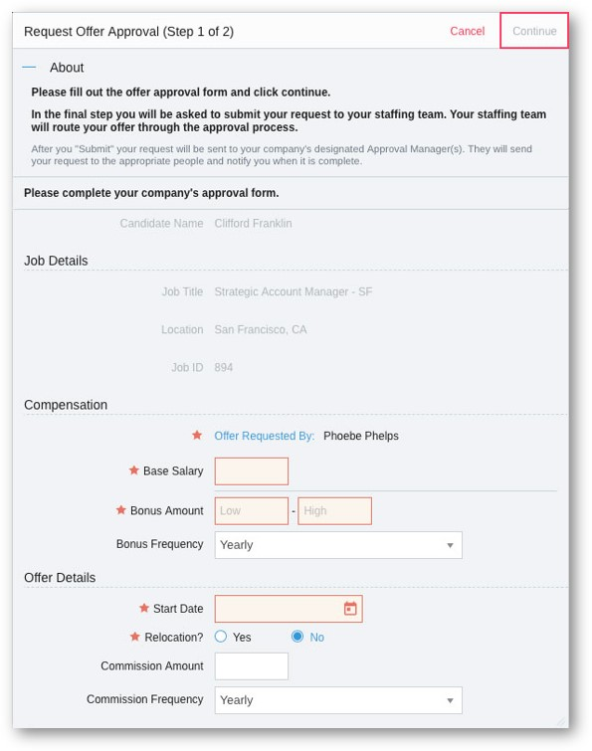
Enter an optional comment and click Submit. Recruiting alerts your Approval Manager that you have submitted the request.
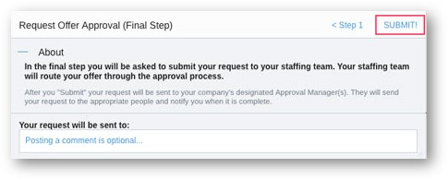
You're finished! Recruiting displays your alert settings for your convenience.
Once your offer is approved & your candidate verbally accepts, please notify HR of the acceptance so they can initiate the Official Offer Letter & Wage Statement to be sent to your new employee.
HOW DO I CHECK THE STATUS OF AN OFFER APPROVAL?
As a Standard User, the Approvals tab on your home dashboard displays all offers related to you, offers you’ve requested, and offers you need to approve. You can see here where the offers stand in the approval process.
